

**STOCK PORTFOLIO MANAGEMENT SYSTEM**

High Level Design & Low Level Design

**Document Control :**

|  |  |  |  |  |  |  |  |  |
| --- | --- | --- | --- | --- | --- | --- | --- | --- |
| **Stock Portfolio Management System** | | | | | | | | |
| Guided by-  **Mr. Sankar** |  |  | |  |  |  |  |  |
| **Date** | **Version** | **Author** | **Brief Description of Changes** | | | | **Approver Signature** | |
| December 07 2022 |  | Sruthi Kavishetti  Devi Priya Putta  Goli Varsha  Guna Swetha Madaka  Jannu Deepthi |  | | | |  | |

# 

1. **INTRODUCTION**

* 1. **Purpose**

The objective of portfolio management is **to create and maintain a personalized plan for investing over the long term in order to meet an individual's key financial goals.** This means selecting a mix of investments that matches the person's responsibilities, objectives, and appetite for risk.

**1.2**  **Scope**

Portfolio managers are financial professionals who work for wealth management firms, pension funds, foundations, insurance companies, banks, hedge funds and other organizations in the securities industry. They **oversee the daily management of investment portfolios on behalf of individual or institutional clients.**

* 1. **Definition**

The stock Portfolio management system is **the art and science of selecting and overseeing a group of investments that meet the long-term financial objectives and risk tolerance of a client, a company, or an institution**. Some individuals do their own investment portfolio management.

* 1. **Overview**

To supply capital - To achieve this task, ownership in a private corporation is sold to the public in the form of shares of stock. Funds received from the sale of stock contribute to the firm’s capital formation.

Toinspiresavings - This inspires people to save their income by making a profit. Continuous purchase and sale of securities on a stock exchange lead to the evaluation of their prices.

Todevelop economy - It helps economic development by supplying the capital to the industries.

To protect fraudulently**-**It is also to ensure that no fraudulence occurs in a transaction.

To do long-term financing - Commercial banks generally disburse the short-term loan. So, supplying long-term finance is an objective of the stock exchange.

**1.5 GENERAL DESCRIPTION**

**1.5.1 HEADER FILES**

* stdio.h
* stdlib.h
* string.h

**2.DESIGN OVERVIEW**

|  |  |
| --- | --- |
| Name of the Module | Top level menu and user interaction.  Single OS authenticated user. |
| Handled by | Devi Priya Putta, Deepthi |
| Description |  |

|  |  |
| --- | --- |
| Name of the Module | Stock master menu for addition, deletion and modification of stock. Stock will not be deleted if a position in a specific stock is existing or there is trade in stock during current FY. |
| Handled by | Varsha Goli, Shruthi, Swetha |
| Description | Developed code on update and delete operations and implemented . |

|  |  |
| --- | --- |
| Name of the Module | Stock trade/contract note addition , deletion and modification. Trade inputs will consists of stock code, Quantity, B or S, Trade Price and Other expenses. |
| Handled by | Deepthi , Shruthi , Devi Priya |
| Description | Researched and developed all the conditions and functions on Buy and sell. |

|  |  |
| --- | --- |
| Name of the Module | Application will maintain daily price movements by a stock closure price provided in a file at a specific location. P&L and MTM calculator and report displayed on selecting a menu |
| Handled by | Swetha, Varsha, Shruthi |
| Description | Developed code in creating sales record and designed dataflow diagrams and flow charts |

|  |  |
| --- | --- |
| Name of the Module | Tax estimate report based on Tax Rules of Current FY. They will be hard coded. Reports |
| Handled by | Deepthi, Devipriya |
| Description | Developed code on update the overall tax reports. |

**3. DETAILED SYSTEM DESIGN**

**3.1 HLD&LLD**

**FLOW CHART**

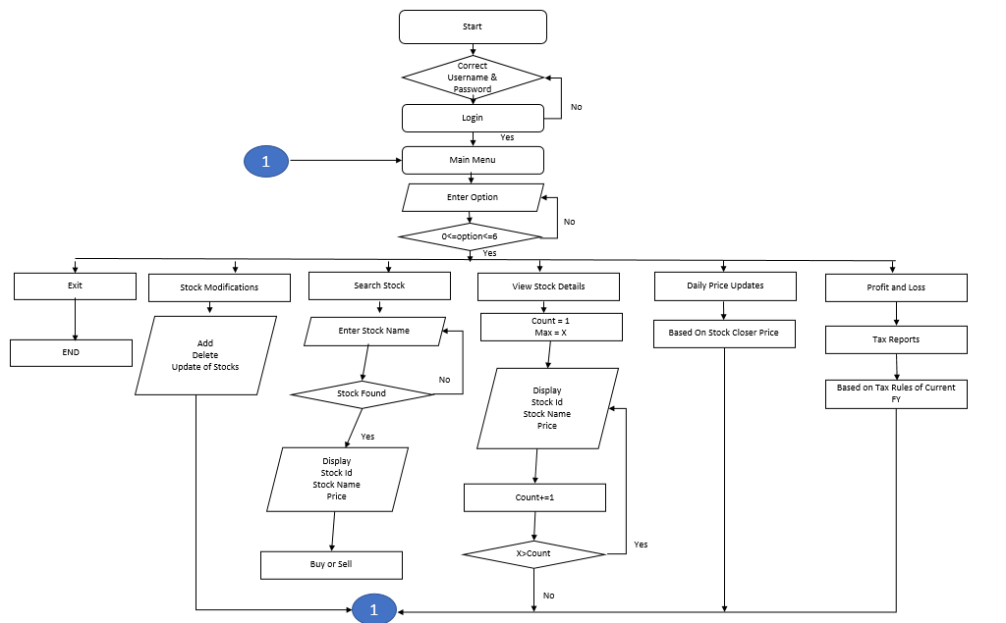

**HLD-High level diagram**

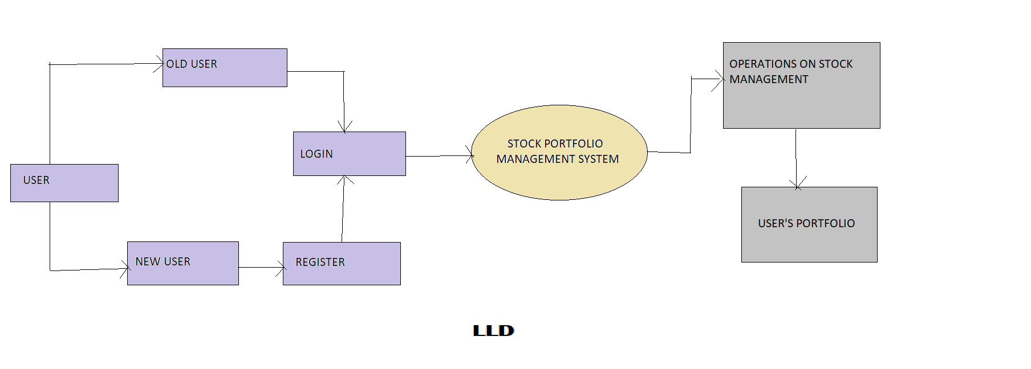

**3.2 DATA FLOW DIAGRAM**

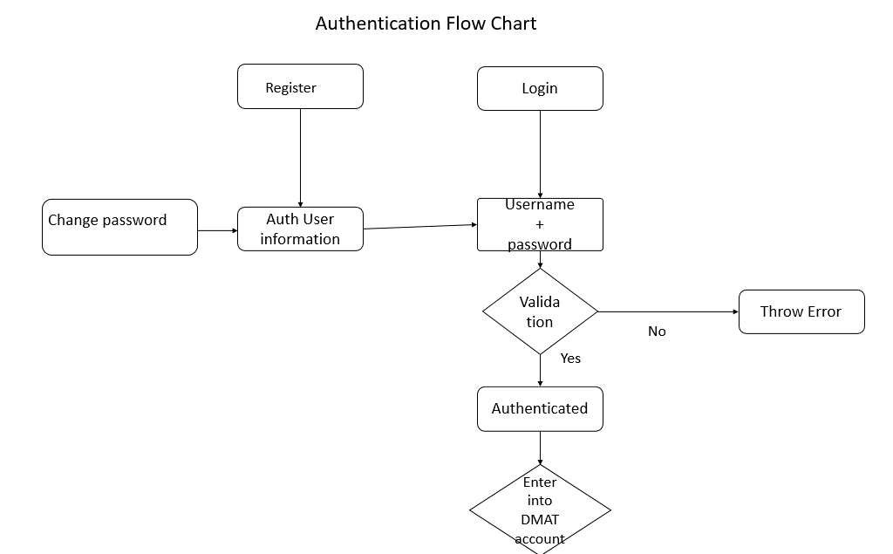

**3.3 DATA OVERVIEW**

​

**4.ENVIRONMENT DESCRIPTION**

**4.1 Time Zone Support:** IST- Kolkata

**4.2 Language Support:** English

**4.3 User Desktop Requirements**

* + 64-bit processor, 1.50 GHz or faster
  + At least 10 GB free hard drive space
  + At least 1 GB RAM Server

**4.3.1** **Integration Requirements**

* + - Language: C
    - Tools: Valgrind
    - Complier: gcc
    - Linux Environment

**4.3.2 Network:** End to End

**4.3.3 Configuration:**

Operating System: Linux environment

**5. Demo**

**(sunny and rainy testcases):**

**TEST_CASE 5.1** sunny testcase** 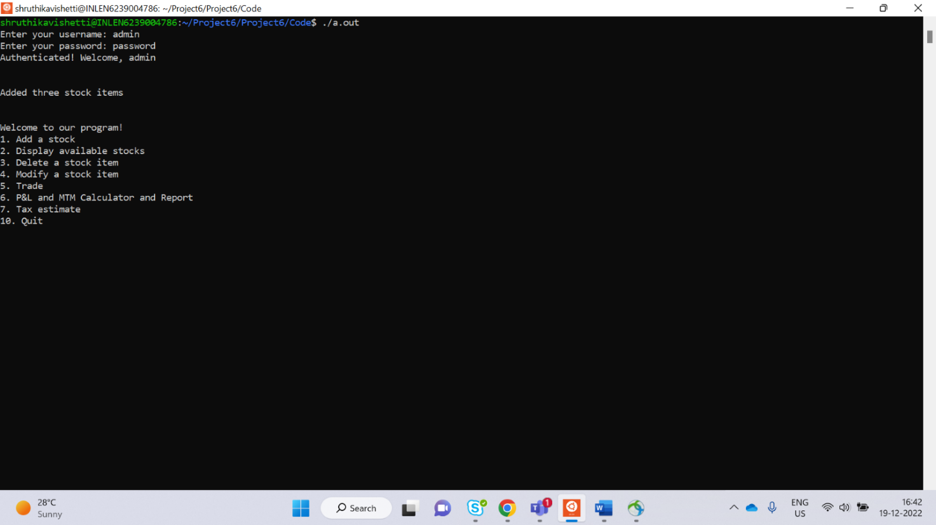:**

**LOGIN**

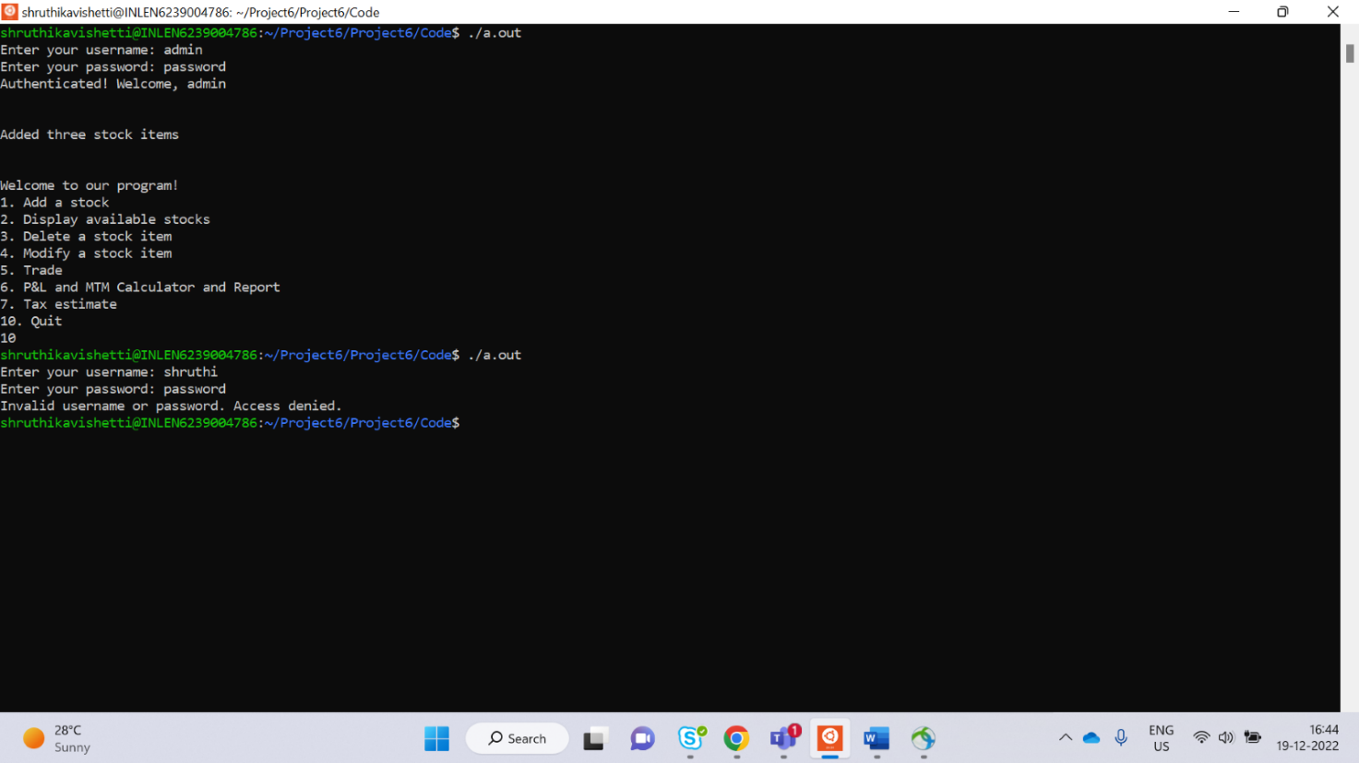

**TEST_CASE 5.2:** sunny testcase

**Menu**

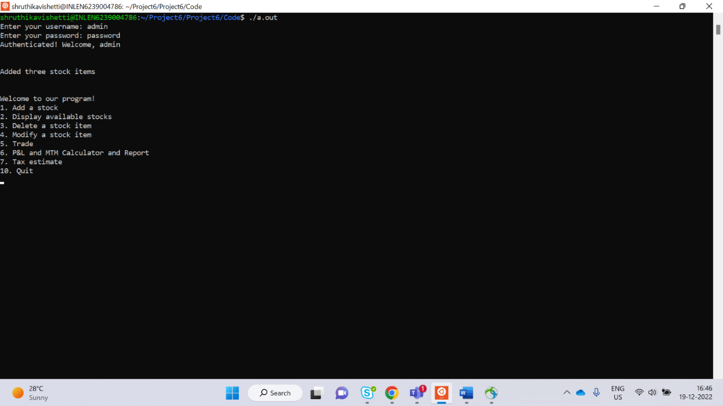

**TEST_CASE 5.3:** sunny testcase

**ADD_STOCK**

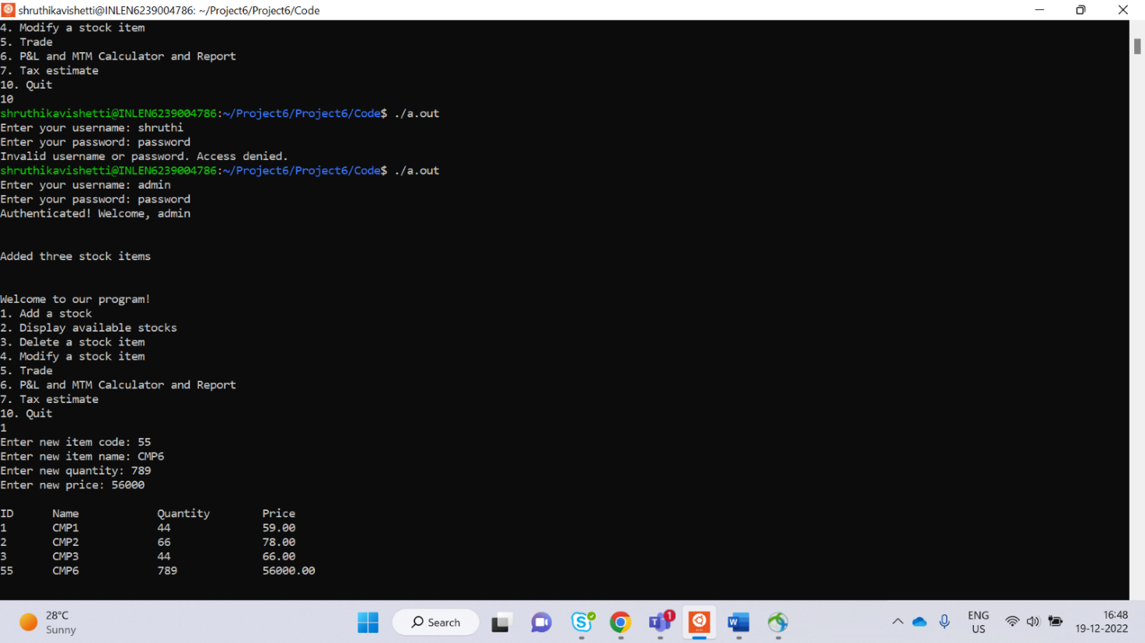

**TEST_CASE 5.4:** sunny testcase

**DISPLAY STOCK**

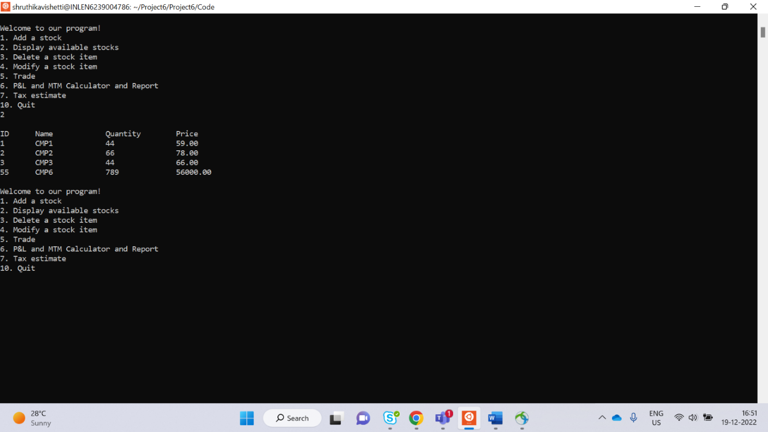

**TEST_CASE 5.5:** sunny testcase

**DELETE STOCK**

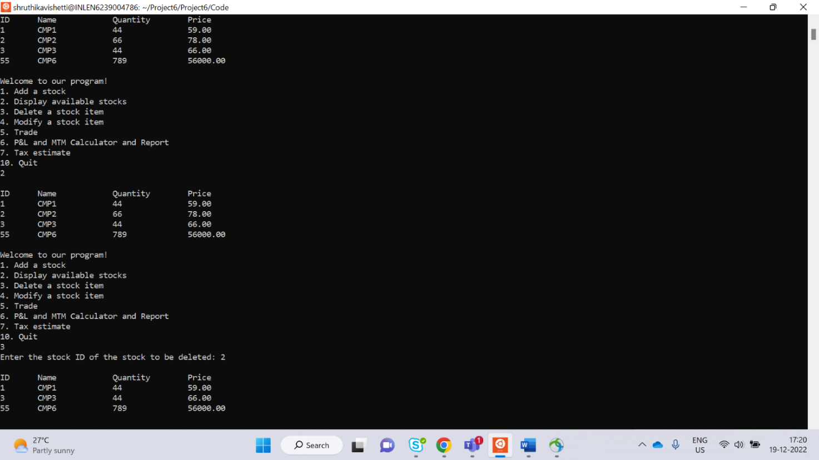

**TEST_CASE 5.6:** sunny testcase

**MODIFY STOCK**

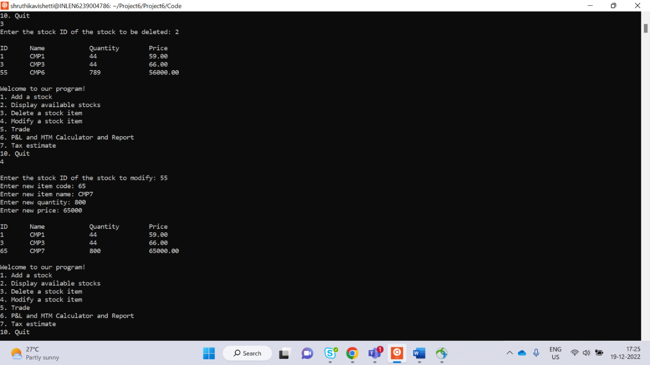

**TEST_CASE**

**TRADE 5.7:** sunny test case

**BUYING**

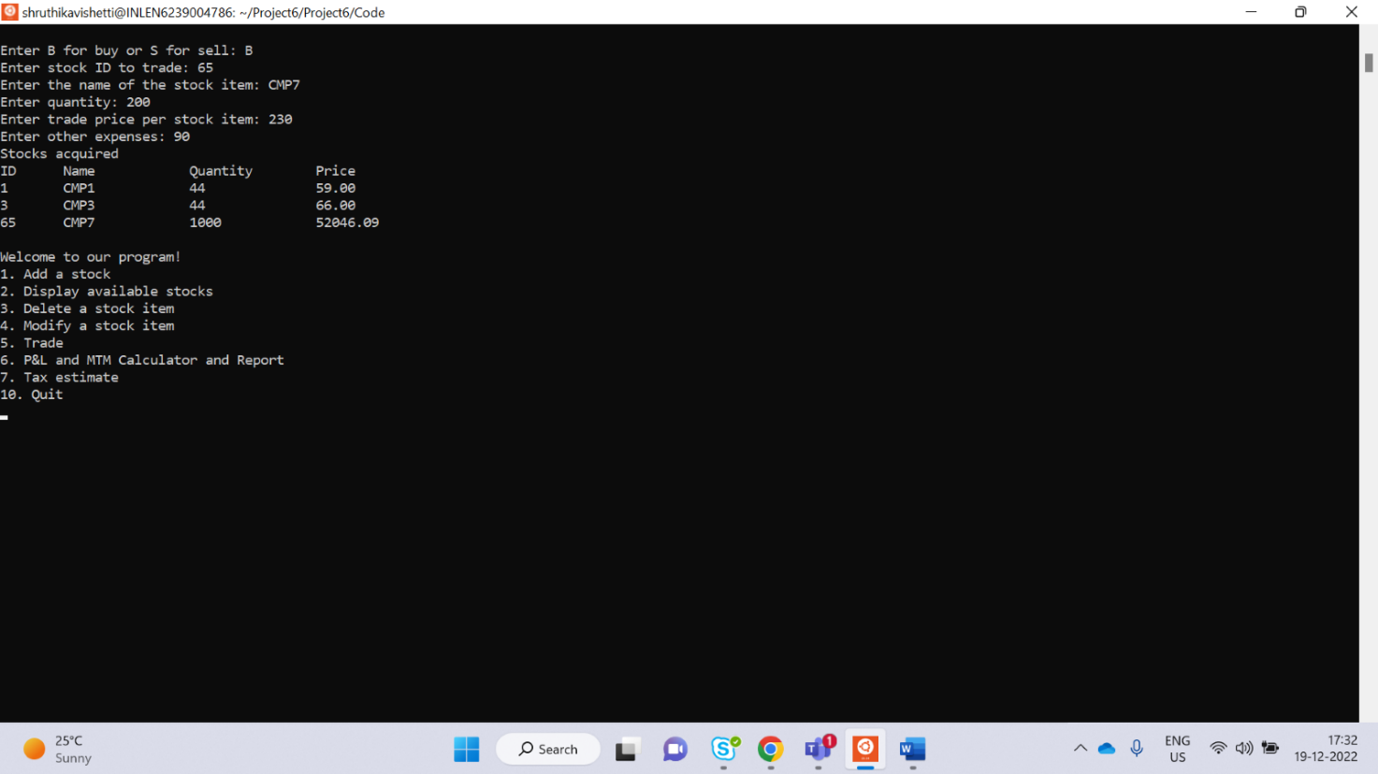

**SELLING**

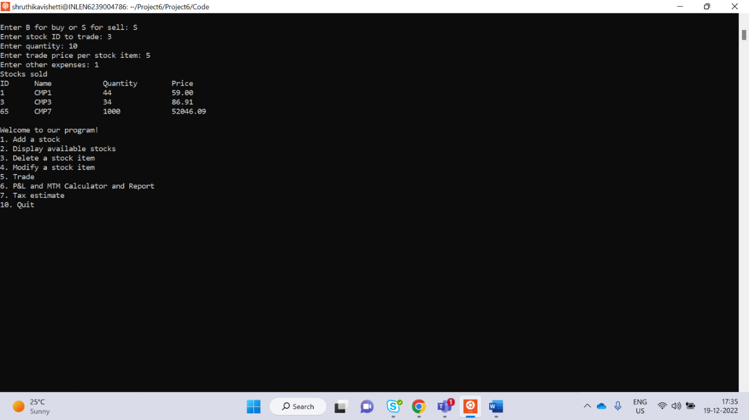

**TEST_CASE 5.8:** rainy testcase

**CALCULATOR**

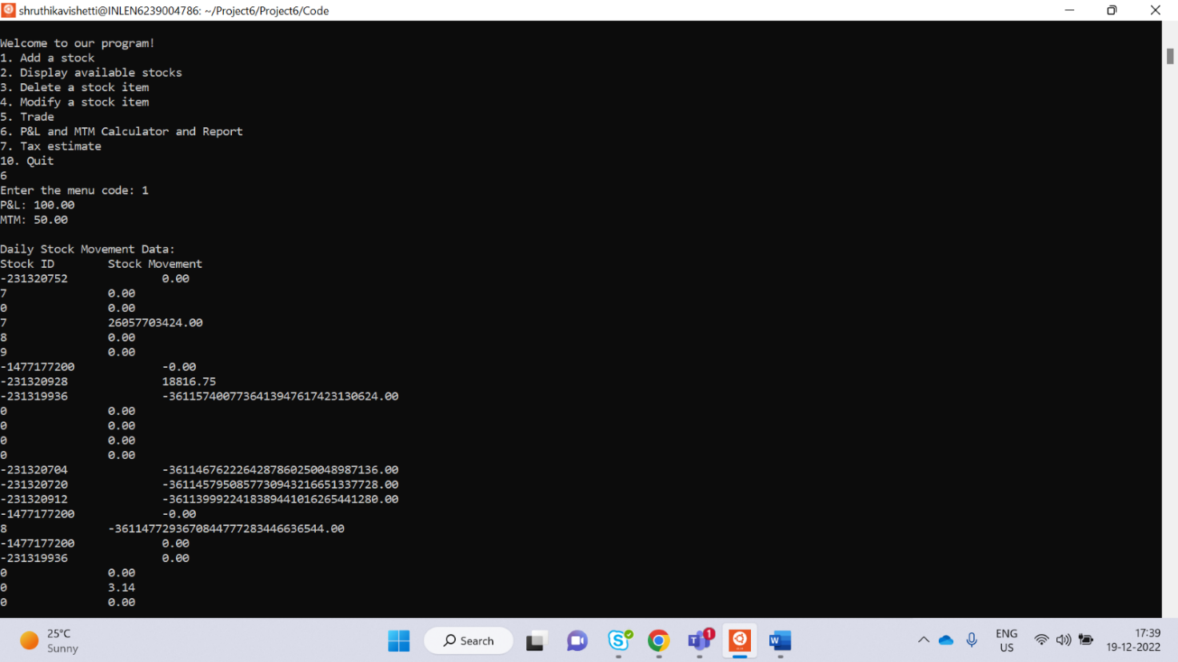

**TEST_CASE 5.9:** rainy testcase

**TAX ESTIMATE**

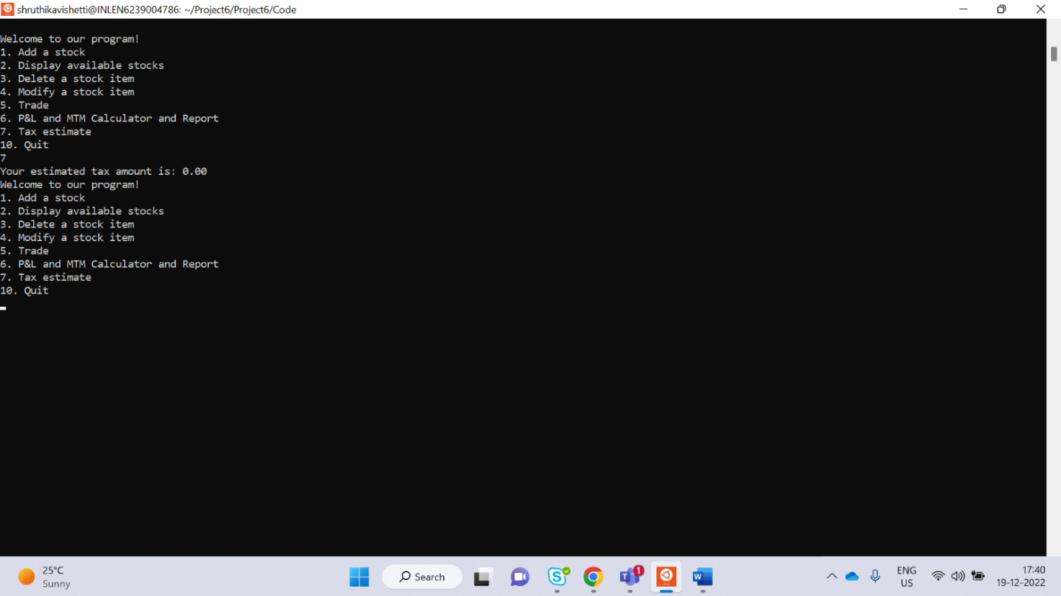

**TEST_CASE 5.10:**

**QUIT**

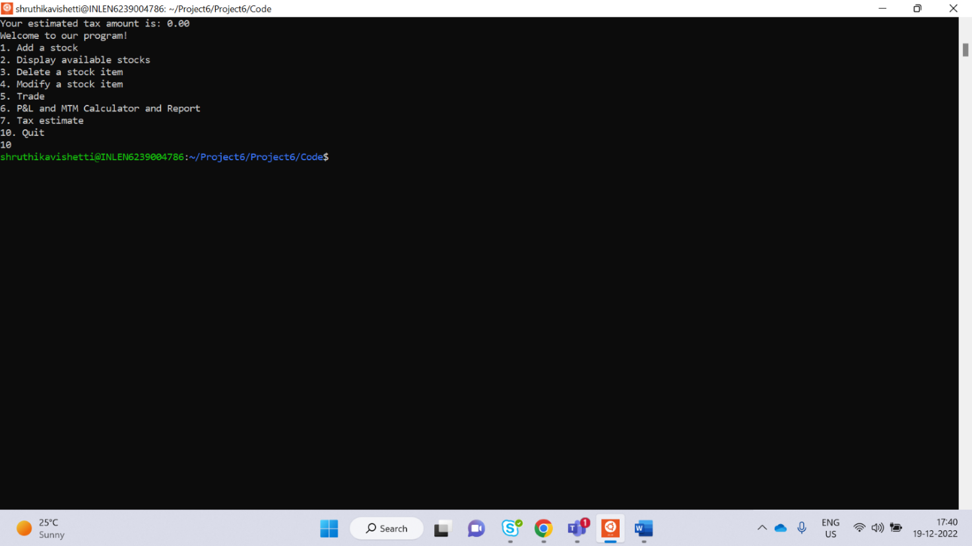

**6. REFERENCES**

The references are:

<https://corporatefinanceinstitute.com/resources/wealth-management/stock-screener/>

<https://www.investopedia.com/terms/m/movingaverage.asp>

<https://www.nirmalbang.com/knowledge-center/use-moving-average-for-buying-stocks.html>

<https://www.nseindia.com/market-data/live-equity-market>

<https://www.researchgate.net/publication/251335107_Market_Timing_With_Moving_Averages>